## Table of Contents

Table of Contents 1

Objective 2

Target Audience 2

Overview 2

Policy Status 2

High Level of Diagram L1 (New Block/unblock policy) 3

Block/Unblock Process 3

Current Process 3

New Process 4

Technical Side 5

Code Files/Functions 5

Database Entities 5

References 6

## Objective

The objective of this document is to understand

1. The overview of policy block/unblock process,
2. Current policy block/unblock process,
3. Desired policy block/unblock process.
4. High Level Diagram
5. The entities used in the process,
6. Understanding of Technical side,
7. Database entities used and code flow.

## Target Audience

1. Developers/QA
2. Business persons

## Overview

The Policy Block/Unblock process works on the schools and block or unblock them on the basis of some criteria. This process run in a scheduled interval.

* The schools are identified for block and unblock.
* Internal and external emails are generated and sent and the school. The schools are blocked/unblocked after this.
* Schools are blocked for non-payment or insufficient usage. (Schools must receive at least 10 GMAT score reports over the previous 12 months, or as an annual average over the past 36 months, whichever is greater). This usage threshold is based on a school as a whole; multiple programs may be represented.
* Schools blocked for non-payment are automatically unblocked when payment has been received.
* Schools blocked for insufficient usage are automatically unblocked when the minimum requirements are met.

Policy Status:

1. Blocked
2. Unblocked
3. Exception

Image 1

## High Level of Diagram L1 (New Block/unblock policy)

## Block/Unblock Process

### Current Process

In the current process the block/unblock process runs daily and users are blocked automatically.

By the daily process, both the internal and external mails are sent and after this the schools are blocked or unblocked immediately. The internal emails are send to the [GMASS, ADI Team, Paula McKay, Shira Stein, Christa Johnson-Perkins, Olivia Pechstein] with the list of schools to be blocked or unblocked. The External emails are send to the school’s primary subscriber with notification of the block/unblock.

The schools can be blocked or unblocked manually too. This can be done in the GDAT-> GMASS-> Subscription-> School Edit page. In the page, the selection section ‘GMASS Policy Block’ have 3 status. Select the status as required(See Image 1 above). The available status are

1. Block: Select the block status, if you want to block the school. For blocked schools the GMASS search service will get disabled.
2. Unblock: Select the unblock status if you want to unblock the school.
3. Exception: Select the exception status, if you want to exclude the school from automatic block/unblock process.

After the selection of status, save it in the database by clicking on the ‘Save’ button. Clicking on save will prompt a message(See Image 2 below). Clicking on ‘Yes’ will send the mails to school’s GMASS subscribers else it will only save but not send any email.

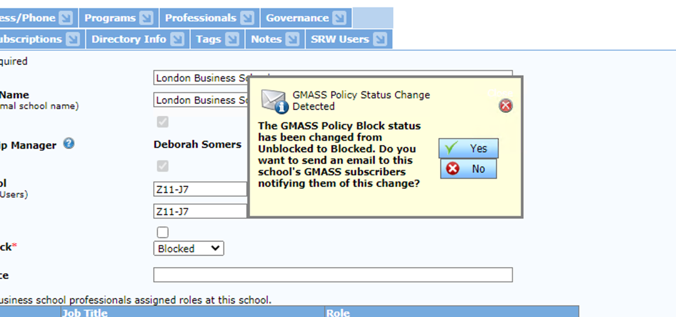

Image 2

### New Process

The new policy unblock will exactly remain same as like the current process except the time lines.

Unlike the current process, the new process will run monthly on a configured date and process the analysis to identify affected schools for block/unblock.

For example, we can take a date of 1st of each month. On every 1st date, the system will perform the block/unblock analysis to identify affected schools and then automatically send the internal email to [GMASS Reports, ADI Team] with the list of schools to be blocked or unblocked. A delay of 7 days is provided after 1st so that the sales staff will have an opportunity to reach out to schools or invoke a Policy Exception. All the manual process can held in these 7 days.

After the completion of these 7 days, i.e. on 7th date of every month, the system will automatically send the external email to the school’s primary subscriber with notification of the block/unblock and the block/unblock automatically applied on the schools based on the schools identified in the analysis performed on the 1st of the month except for the schools on which manual process has been done in these 7 days.

## Technical Side

The main functionality is achieved with the system procedures. Both for manual and automatic process 2 different procedures work(Given below). These automatic process run on the schedule by SQL JOB which run daily.

### Code Files/Functions

Solution used: GDAT

Files/Classes and functions:

Organiation/BusinessSchoolEdit.aspx

void SaveChanges (bool? sendGMASSPolicyBlockStatusEmail = null){…}

### Database Entities

Procedures and their purpose:

GMASS.dbo.spSaveGMASSPolicyBlock

1. Update the data table ‘GMASSPolicyBlock’ to update/insert the policy block/unblock status.
2. To send emails, get subscribers using tables g2_vSubscriber and g2_vSubscription.
3. Use data tables ‘TableIDs’ and ‘CorrespondenceEvent’ to send the emails. Get NextKey values from TableIDs’ and insert record in CorrespondenceEvent’ table.
4. Insert records into JobLog also using function spInsertJobLog.
5. Currently this procedure is called for manual policy block/unblock status updates.

spJOB_NightlyMaster

Master Stored Proc that is run nightly by the SQL Server Jobs Agent

spJOB_GMASSPolicyBlockNightlyStatusUpdates

1. Get called from spJOB_NightlyMaster
2. Update the JobLog data table.
3. Get AllSchoolsWithCalculatedStatus using tables BusinessSchool and GMASSPolicyBlock.
4. Update the status based on the logic for Exception /block/unblock
5. Send the Emails.

Tables:

1. GMASS.dbo.GMASSPolicyBlock
2. GMASS.dbo.g2_vSubscriber
3. GMASS.dbo.g2_vSubscription
4. GMASS.dbo.JobLog
5. GMASS.dbo.TableIDs’
6. GMASS.dbo.CorrespondenceEvent’
7. GMASS.dbo.JobLog
8. GDATWEb.dbo.SystemValues
9. GDATWeb.dbo.BusinessSchool

Functions

1. spInsertJobLog
2. g2_fnConvertDateToDateNoTime

## References

* JIRA Ticket - <https://gmacdev.atlassian.net/browse/GMASS-878>
* Source Code of Application
* Database entities